Scott Roberts
EDUI 635000
1/30/2018

Case Study for Technology Implementation
All educators are looking for ways to help students learn more effectively. There is a lot of buzz about SMART Boards. This paper looks into the impact implementing SMART Boards had on the students and teachers within the elementary classrooms of the Park Street School in New Brunswick.
Background
In 2007, researchers at the University of New Brunswick partnered with a local elementary school, Park Street Elementary, and SMART Technologies (the maker of SMART Boards) decided to implement SMART Board technology in all the classrooms from kindergarten to fifth grade. The purpose of the project was to “document the conceptualization and implementation of the initiative, as well as to investigate potential outcomes or changes related to instructional knowledge and practices, student engagement in learning, and staff development and collaboration.”(Morrison & Kirby, 2008)
Park Street Elementary is a K-5 public school in New Brunswick, Canada. The 420 students have access to both English and French Immersion curriculum.
Description
During the summer of 2007 25 SMART Board systems and their accompanying projectors were permanently mounted in each classroom. Over the following year, teachers were surveyed three times, classrooms were observed, and three grade level focus group sessions were held. Much emphasis was placed upon providing teachers with the tools they need, such as grade level professional learning teams, use of evidence-informed practices, and the ability to create enriched learning environments.
There were four goals articulated for the project were:
- Teach teachers how to confidently use SMART Board technology
- Enhance instructional applications of technology
- Increase professional development amongst teachers
- Increased student engagement.
To ensure those goals were met, specific inputs, actions, outputs, and outcomes were defined. These goals clearly show attention to detail and provides objectives for all members of the school community to strive for.
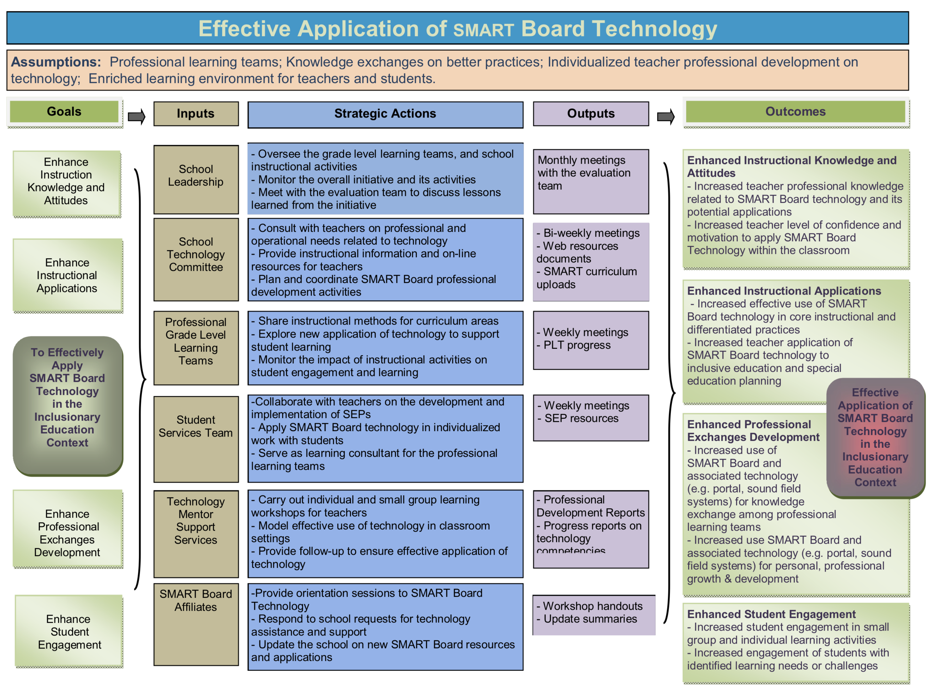
There are a number of things that happened during this rollout that worked very well. Despite only one of teachers having using a SMART Board in the previous year, teachers reported that having daily access to SMART Board technology in their classroom increased educator participation and staff collaboration in the project(Morrison & Kirby, 2008).
The SMART Board rollout implemented an innovative idea that I have not seen before. Rather than cram everything educators needed to know about using a SMART Board into one or two days of excruciatingly painful training, educators were given individualized tutorial sessions. Staff had filled out a needs assessment survey to assess their proficiency with technology, and tutorial plans were differentiated for each teacher. These tutorial sessions were only 20 – 30 minutes long and occurred during the school day. The school even ensured that substitute teachers were provided to facilitate educators attendance at their training.
The training for teachers continued after the tutorials were completed. “Natural mentorships emerged among teachers with higher levels of proficiency and those who were new users.”(Morrison & Kirby, 2008) This helped foster positive and optimistic attitudes towards using SMART Boards.
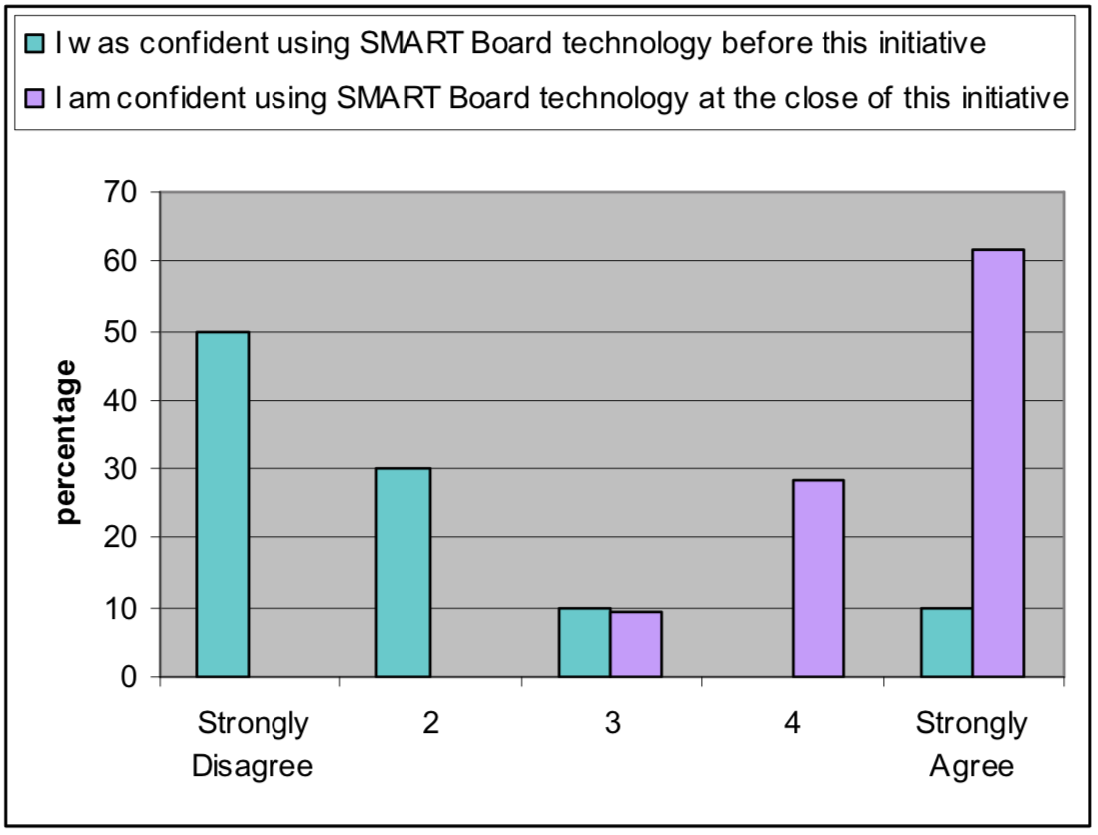
These technology optimistic attitudes resulted in a number of instructional changes. Teachers began to use online resources and educational DVDs more often in their classrooms. Students were able to demonstrate their learning by making and presenting multi-media projects. Most teachers, approximately 95%, used their SMART Board on a daily basis.
Suggestions
Not all of the benefits noted were strictly due to the SMART Board system. Teachers at this school did not have classroom projectors prior to the project, and many of the improvements listed could be attained by a projector without SMART Board technology.
I suggest that before a district decides to roll-out SMART Board technology that they consider the incremental differences between projectors and projectors with SMART Board type systems. Remarks made by the papers authors such as “One spontaneous discussion regarded the size of the moon in comparison to the province of New Brunswick resulted in immediate access of an internet search engine to research specific dimensions. This immediate access to Internet resources allowed for the making the most of a teachable moment.”(Morrison & Kirby, 2008) This great moment was not enabled by a SMART Board, but merely by the use of a projector connected to a computer.
Implication & Conclusion
Although many issues can rear their ugly heads when implementing expensive and unfamiliar technology, Park Street Elementary saw many positive influences from their addition of technology. Teachers reported greater ease in engaging students and maintaining their attention. Observational data supported the teacher’s reporting.
A word of caution is advised since not all students respond similarly to SMART Board focused activities. It was noted by Morrison & Kirby that “students with specific learning needs were less engaged with the technology than were their peers.”(Morrison & Kirby, 2008) They go on to say that even in traditional classrooms, there was the standard student pattern of the “keen” students raising their hands while others sat silently.
Another gotcha may be related to student attention and engagement. It was noted that when classroom sound reinforcement was used, students paid more attention and maintained attention for extended periods of time.(Morrison & Kirby, 2008) It’s unclear whether all classrooms in the study had sound reinforcement systems or whether they were used on a daily basis. This paper’s author has noticed a large difference in student attention when using classroom sound reinforcement and is unable to differentiate between increased attention due to audio or SMART Board usage. Further studies are needed to provide clarity on the issue.
SMART Boards and other Interactive White Board systems provide many benefits for the classroom teacher. Other school districts should implement these systems as budgets allow, remembering that incremental steps such as classroom projectors and audio reinforcement systems can produce substantial gains at a smaller cost than a SMART Board.

Works Cited

Morrison, B., & Kirby, P. (2008). Applying SMART board technology in elementary school classrooms: Investigation of a school-wide initiative. Health and Education Research Group, Faculty of Education, University of New Brunswick.

